**Temirlan Turar SE-2431**

**Assignment #2 - CSS Styling (Colors, Fonts,**

Layout)

**TASK 1**

# HTML Code Description

**Navigation System**

* **Task Navigation Bar**: A dedicated navigation section provides links to all four tasks, allowing easy switching between different assignments
* **Main Navigation**: Internal page navigation within the current task
* **Active State Management**: Visual indication of the current page using active class

**Layout Components**

* **Header Section**: Contains the main website title with proper heading hierarchy
* **Sidebar Menu**: Left-aligned navigation panel with list-based menu items
* **Content Area**: Main content section with descriptive text and headings
* **Footer**: Copyright information and legal notices

**Semantic Markup**

* Proper use of heading tags (h1, h2, h3) for content hierarchy
* Unordered lists for menu items
* Division of content into logical sections using div elements
* Meaningful ID names for major sections

**Accessibility Features**

* Descriptive link text
* Proper heading structure
* Semantic container elements
* Alt text ready for images (though not used in this task)

# 

# CSS Code Description

# CSS Reset and Base Styles

* Complete margin and padding reset using universal selector
* Border-box box-sizing implementation for consistent sizing calculations
* Base font family set to Arial with sans-serif fallback
* Minimum height setting to ensure footer placement

Layout Management

* **Flexbox Implementation**: Modern flexbox layout for entire page structure
* **Vertical Stacking**: Column-direction flex layout for natural content flow
* **Sticky Footer**: Automatic footer positioning using margin-top: auto
* **Responsive Container**: Flexible main container with proper spacing

Navigation Styling

* **Dual Navigation Systems**: Separate styling for task navigation and main navigation
* **Hover Effects**: Smooth color transitions on interactive elements
* **Active State Indication**: Clear visual feedback for current page
* **Centered Alignment**: Proper text alignment for navigation elements

Component Styling

* **Header Design**: Navy blue background with white text and centered content
* **Sidebar Layout**: Light gray background with bordered container and rounded corners
* **Content Area**: Light background with proper padding and border definition
* **Footer Style**: Consistent header matching with centered text

Typography and Colors

* **Color Scheme**: Navy blue and light cyan color palette with appropriate contrasts
* **Font Hierarchy**: Clear visual distinction between heading levels
* **Text Readability**: Proper line height and spacing for comfortable reading
* **Consistent Sizing**: Uniform padding and margin values throughout

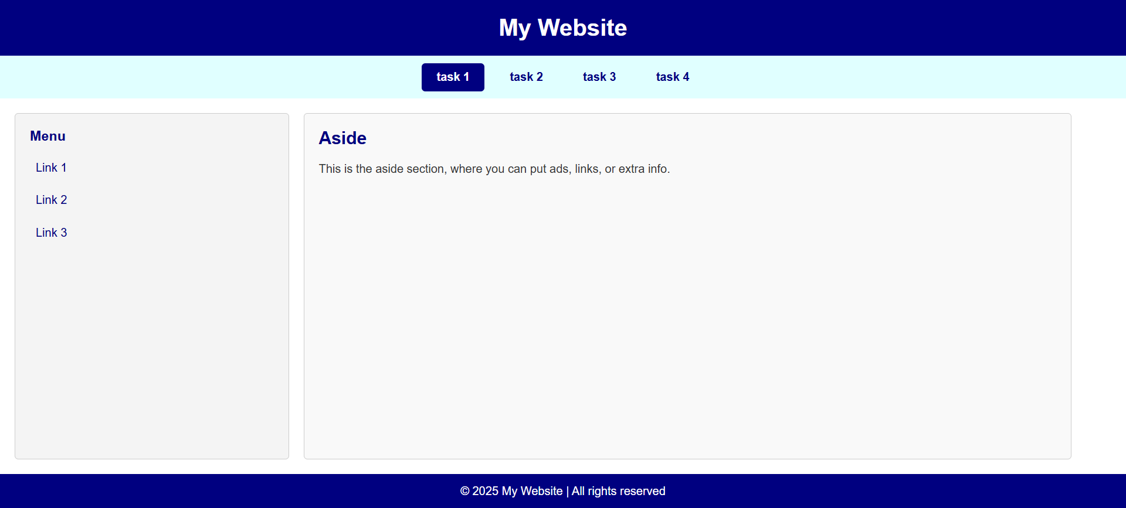

**TASK 2**

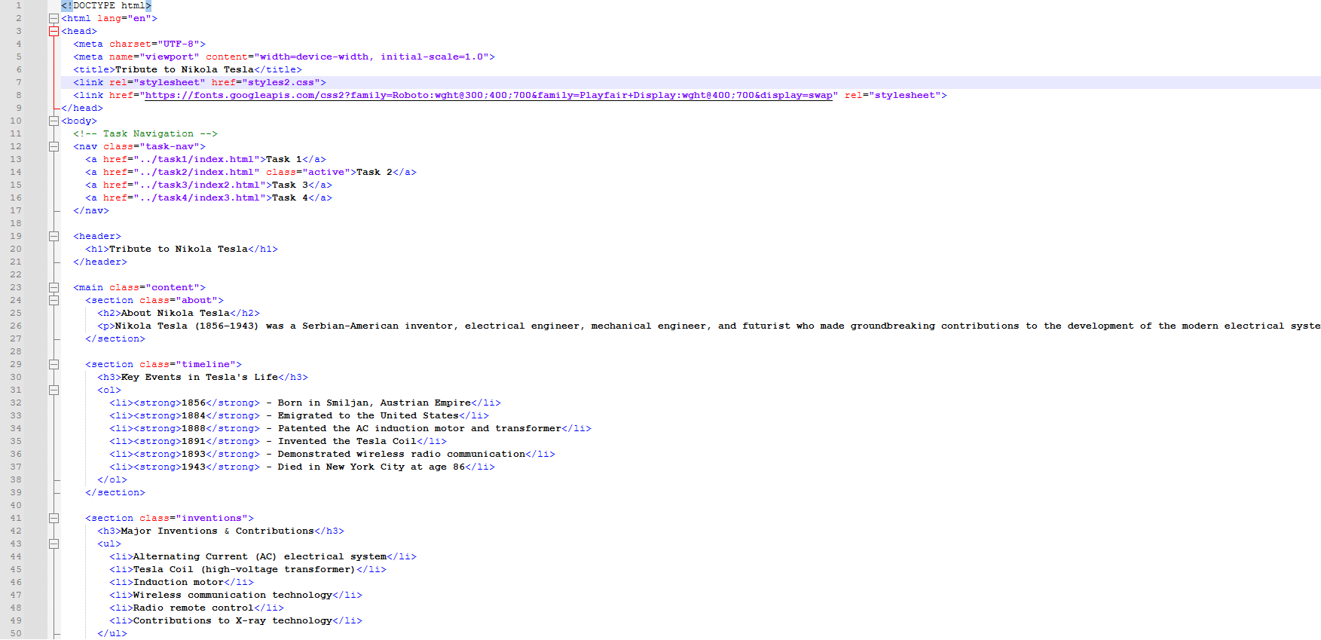 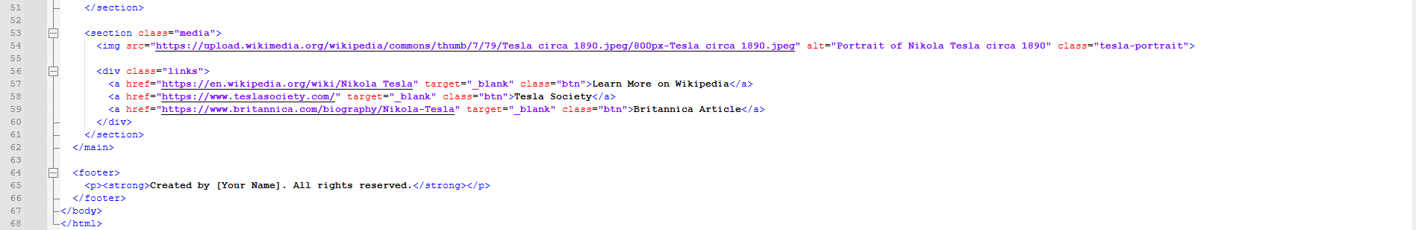

# HTML Code Description

# Navigation System

* **Universal Task Navigation**: Consistent navigation bar across all tasks with active state indication
* **Visual Hierarchy**: Clear distinction between task navigation and page content

Semantic Sections

* **Header Section**: Prominent hero section with main tribute title
* **About Section**: Biographical information with proper heading structure
* **Timeline Section**: Ordered list of key life events with semantic markup
* **Inventions Section**: Unordered list of major contributions
* **Media Section**: Image and external links with proper attributes
* **Footer**: Copyright information with strong emphasis

Content Organization

* **Hierarchical Headings**: Proper use of h1, h2, h3 for information architecture
* **List Structures**: Both ordered (timeline) and unordered (inventions) lists
* **External Links**: Three relevant external resources with target="_blank"
* **Image Implementation**: Wikipedia-sourced image with descriptive alt text

Interactive Elements

* **Styled Buttons**: Attractive call-to-action links with hover effects
* **External References**: Properly attributed external resources
* **Accessibility Features**: Descriptive alt text and link text

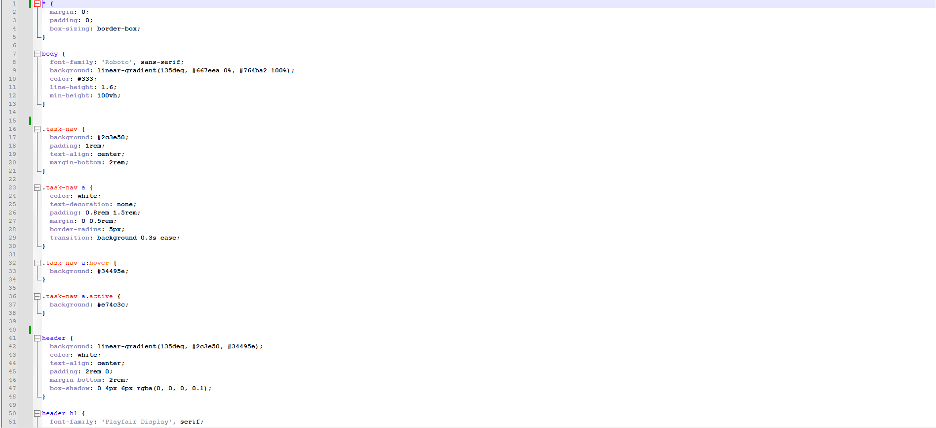 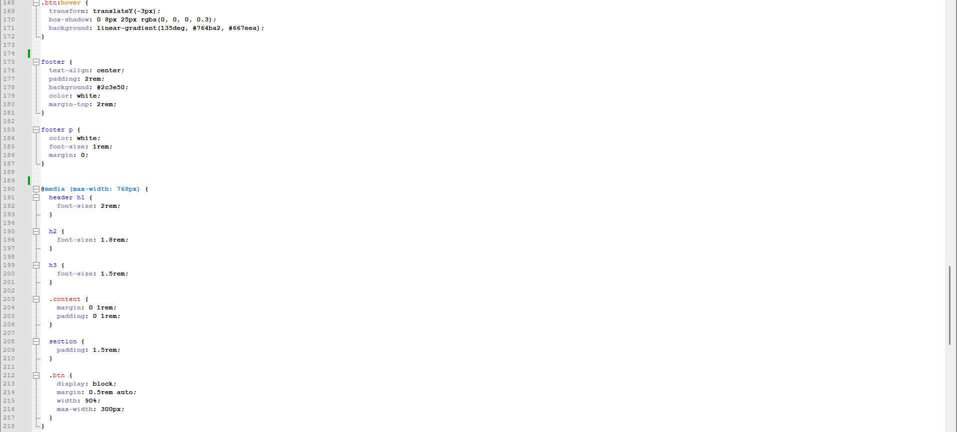

# CSS Code Description

# Base Setup and Reset

* **Complete CSS Reset**: Margin, padding, and box-sizing normalization
* **Google Font Integration**: Roboto for body text and Playfair Display for headings
* **Gradient Background**: Modern CSS gradient for visual appeal
* **Global Line Height**: Enhanced readability settings

Navigation Styling

* **Consistent Task Navigation**: Uniform styling across all tasks
* **Active State Management**: Visual indication of current task
* **Hover Effects**: Smooth background transitions
* **Centered Layout**: Proper alignment and spacing

Header Design

* **Hero Section**: Gradient background with text shadow for depth
* **Typography Hierarchy**: Font pairing with size and weight variations
* **Box Shadow Effects**: Subtle shadow for dimensional appearance
* **Padding and Spacing**: Ample whitespace for visual balance

Content Container

* **Max-width Constraint**: Content width control for large screens
* **Centered Layout**: Automatic margin centering
* **White Background**: Clean content area with rounded corners
* **Shadow Effects**: Prominent shadow for container elevation

Section Styling

* **Visual Separation**: Border-bottom between sections
* **Consistent Padding**: Uniform spacing within sections
* **Last-child Exception**: Logical removal of final border

Typography System

* **Heading Styles**: Distinct styling for h2 and h3 elements
* **Border Accents**: Left border for h2, bottom border for h3
* **Paragraph Styling**: Optimal font size and line height
* **Color Hierarchy**: Navy blue for headings, gray for body text

List Design

* **Indented Lists**: Proper margin implementation
* **List Style Variations**: Decimal for ordered, square for unordered
* **ListItem Spacing**: Consistent vertical rhythm
* **Strong Emphasis**: Color variation for highlighted text

Image Presentation

* **Responsive Images**: Max-width: 100% for fluid scaling
* **Border and Shadow**: Elegant framing with multiple effects
* **Rounded Corners**: Modern 15px border radius
* **Hover Animation**: Subtle scale transformation on hover
* **Center Alignment**: Automatic margin centering

Button/Link Styling

* **Gradient Backgrounds**: Modern CSS gradient effects
* **Button-like Appearance**: Padding, rounding, and uppercase text
* **Hover Transformations**: 3D lift effect with enhanced shadow

 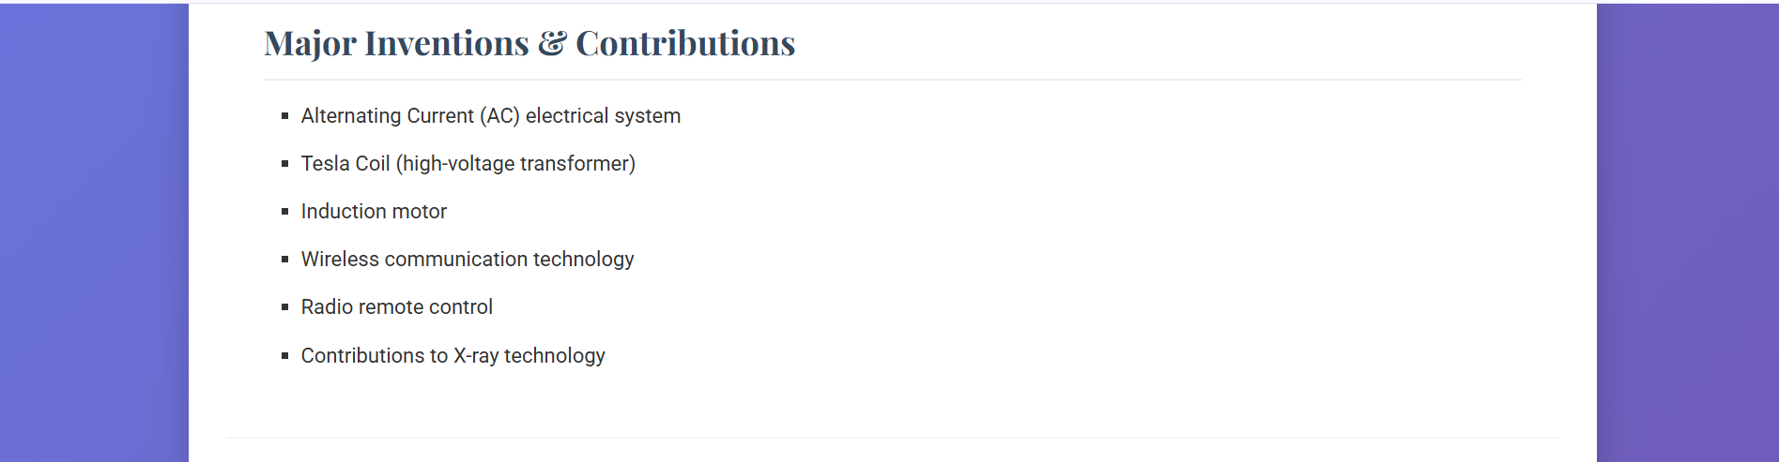 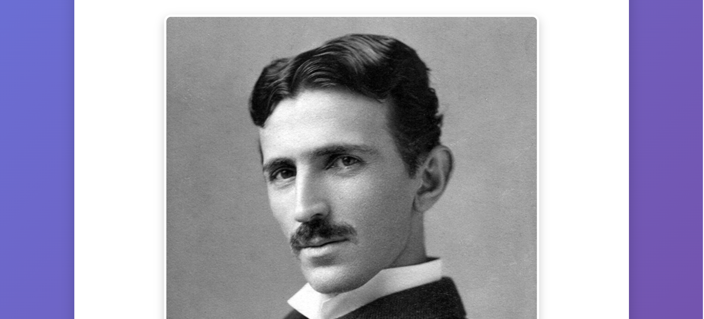 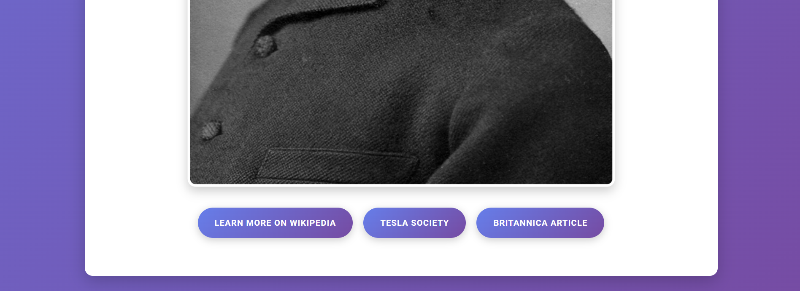

**TASK 3**

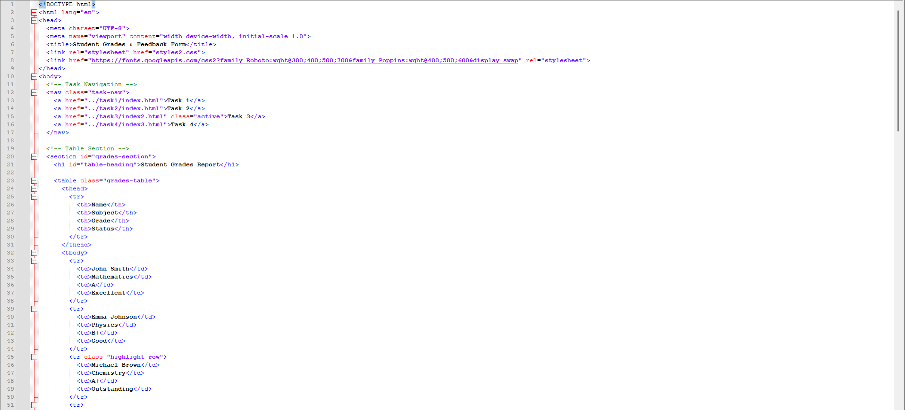 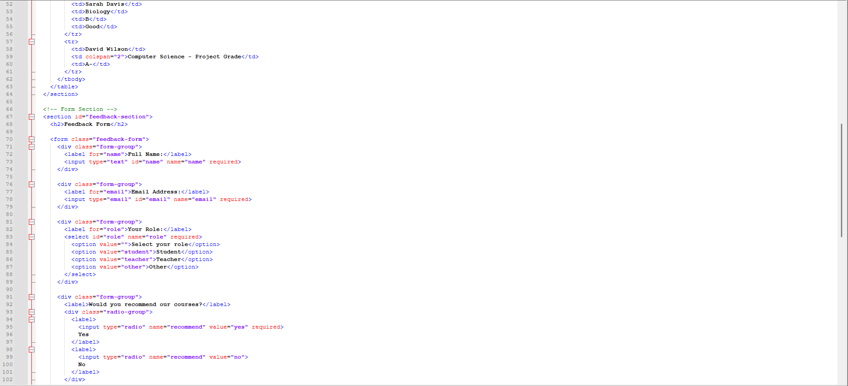

# HTML Code Description

# Navigation System

* **Task Navigation Bar**: Consistent navigation across all tasks with visual active state indication
* **Section Separation**: Clear division between table and form sections using semantic section tags

Table Implementation

* **Semantic Table Structure**: Proper use of thead, tbody, and th elements
* **Data Organization**: Four columns (Name, Subject, Grade, Status) with sample data
* **Special Attributes**: colspan for merged cells and class for highlighted rows
* **Accessibility**: Proper table headers and structured data presentation

Form Construction

* **Complete Form Elements**: Includes all required input types (text, email, select, radio, textarea, submit)
* **Logical Grouping**: Field organization using div containers with form-group class
* **Label Association**: Proper use of for attributes connecting labels to inputs
* **Validation Attributes**: Required attributes for mandatory fields
* **Radio Button Group**: Grouped radio inputs with shared name attribute

Form Fields Detail

* **Text Input**: Name field with required validation
* **Email Input**: Email field with type validation
* **Select Dropdown**: Role selection with multiple options
* **Radio Buttons**: Yes/No recommendation question
* **Textarea**: Comments field with placeholder text
* **Submit Button**: Form submission trigger

Semantic Organization

* **Section Elements**: Clear content separation using section tags
* **Heading Hierarchy**: Proper use of h1, h2 for section titles
* **ID Attributes**: Unique identifiers for main sections
* **Class Usage**: Consistent naming convention for styling hooks

# CSS Code Description

## Base Configuration

* **CSS Reset**: Complete margin, padding, and box-sizing normalization
* **Google Fonts**: Roboto and Poppins font families for typography hierarchy
* **Gradient Background**: Modern background gradient for visual appeal
* **Global Settings**: Minimum height and line height for consistency

Task Navigation

* **Consistent Styling**: Uniform navigation bar across all tasks
* **Active State**: Visual indication of current task
* **Hover Effects**: Smooth background transitions
* **Responsive Design**: Flexible spacing and padding

Table Section Styling

* **Container Design**: White background with rounded corners and shadow
* **Heading Style**: Customized h1 with bottom border accent
* **Spacing Management**: Proper margins and padding throughout

Table Design

* **Full-width Table**: 100% width with collapsed borders
* **Header Styling**: Gradient background with white text and bold weight
* **Cell Design**: Consistent padding, centered text, and vertical alignment
* **Zebra Striping**: Alternate row colors using nth-child pseudo-class
* **Hover Effects**: Row highlighting on mouseover
* **Special Row**: Highlighted row with distinct background gradient
* **Border System**: Consistent border styling for all cells

Form Section Design

* **Section Container**: White background with shadow and rounded corners
* **Heading Style**: Custom h2 with proper spacing and color

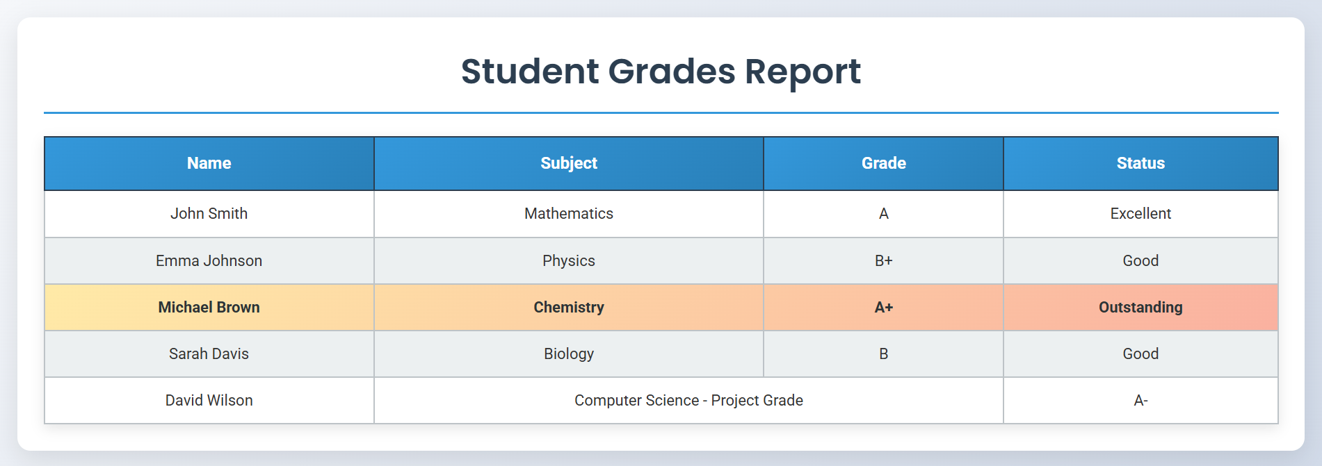 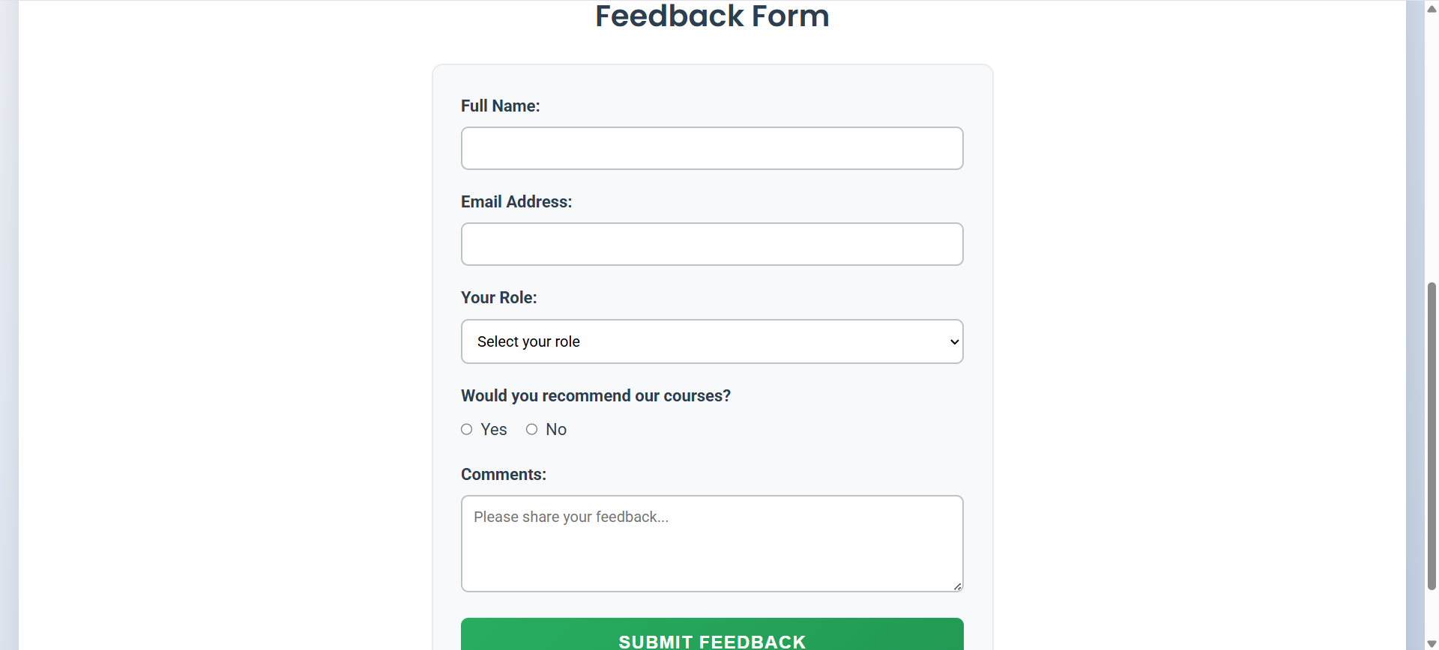

TASK 4

# HTML Code Description

# Navigation System

* **Universal Task Navigation**: Consistent navigation bar across all tasks with active state management
* **Visual Hierarchy**: Clear separation between task navigation and main content

Header Section

* **Main Title**: Prominent h1 heading for project name
* **Subtitle**: Supporting paragraph for additional context
* **Professional Design**: Clean, centered layout with proper spacing

Project Description

* **Structured Section**: Dedicated area for project overview
* **Clear Typography**: Proper heading hierarchy with h2
* **Detailed Explanation**: Comprehensive project description paragraph

Sitemap Visualization

* **Visual Hierarchy**: Main home item with secondary navigation items
* **Grid Layout**: Responsive container with flexbox arrangement
* **Color Coding**: Distinct colors for main and secondary items
* **Representational Design**: Abstract visualization of website structure

Wireframe Components System

The wireframe system includes 5 detailed page layouts:

1. Home Page Wireframe

* **Header/Footer Placeholders**: Consistent across all wireframes
* **Hero Section**: Title, subtitle, and call-to-action button
* **Feature List**: Four key system features with placeholder indicators
* 2. Dashboard Wireframe
* **Statistics Grid**: 2x2 grid of metric boxes
* **Chart Container**: Placeholder for data visualization
* **Task List**: Three upcoming tasks with checkbox indicators
* 3. Clients Management Wireframe
* **Toolbar**: Search, filters, and add button
* **Table Structure**: Header row and two data rows
* **Column Layout**: Four-column data representation
* 4. Sales Funnel Wireframe
* **Funnel Visualization**: Four-stage sales process
* **Stage Containers**: Individual components for each funnel stage
* **Details Area**: Placeholder for additional information
* 5. Reports Wireframe
* **Filter Bar**: Period and report type selection
* **Chart Area**: Dual chart containers (bar and pie)
* **Performance Table**: Header and data rows with grid layout

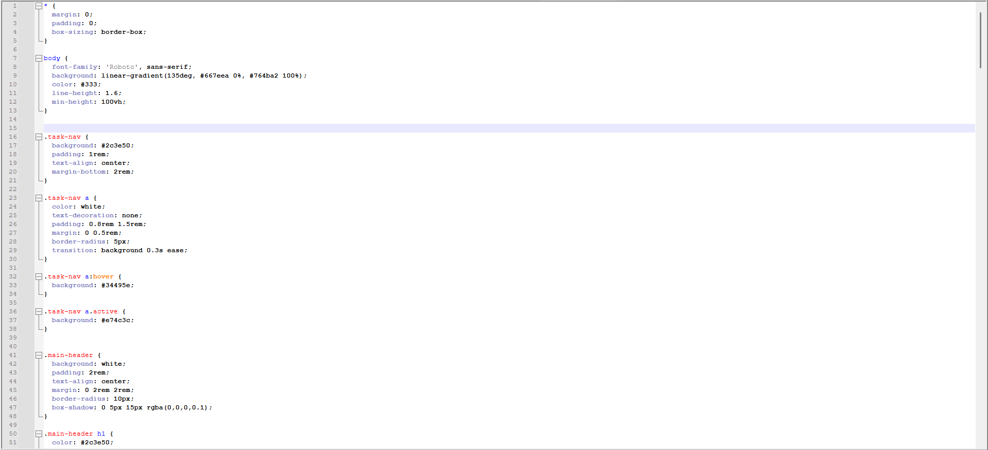 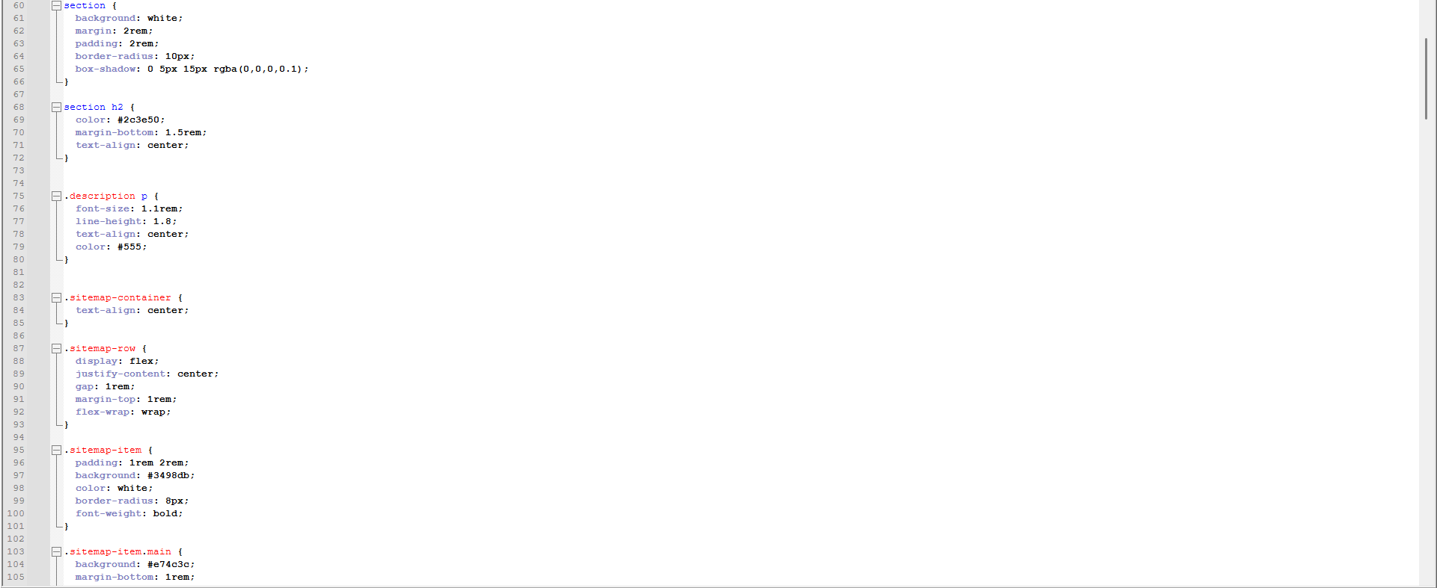 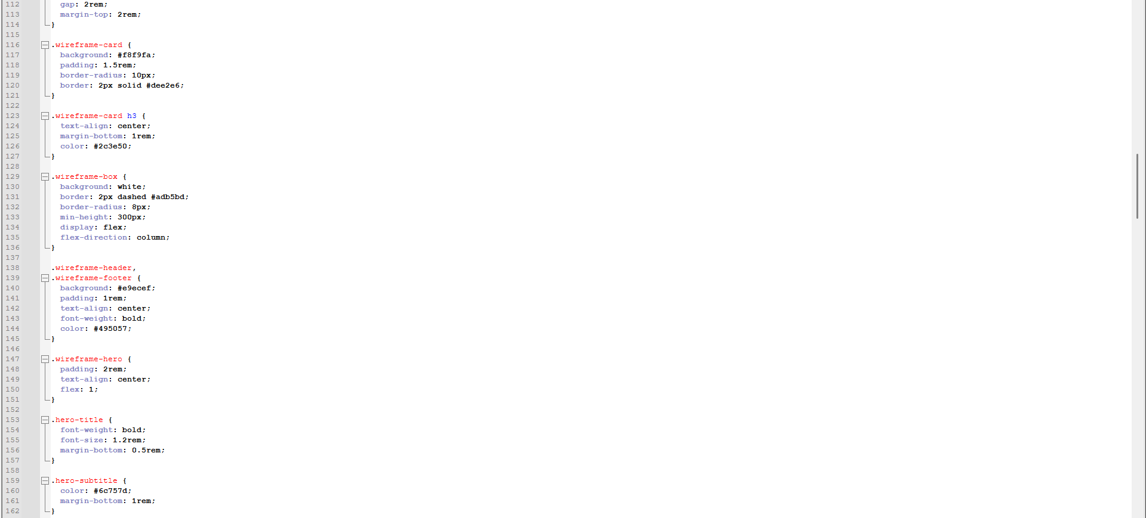

# CSS Code Description

# Base Configuration

* **CSS Reset**: Complete margin, padding, and box-sizing normalization
* **Google Fonts**: Roboto font family for clean, modern typography
* **Gradient Background**: Professional blue-to-purple gradient
* **Global Settings**: Minimum height and line height consistency

Task Navigation

* **Dark Background**: High-contrast navigation bar
* **Hover Effects**: Smooth background transitions
* **Active State**: Red background for current task indication
* **Consistent Styling**: Uniform with other tasks

Main Header Design

* **White Background**: Clean container with shadow effect
* **Centered Text**: Professional alignment
* **Color Hierarchy**: Dark blue for heading, gray for subtitle
* **Rounded Corners**: Modern 10px border radius

Section Styling

* **Consistent Design**: White background with shadow and rounded corners
* **Proper Spacing**: Uniform margins and padding
* **Heading Treatment**: Centered h2 with color consistency

Description Section

* **Text Formatting**: Optimal font size and line height
* **Centered Alignment**: Professional text presentation
* **Color Scheme**: Dark gray for readability